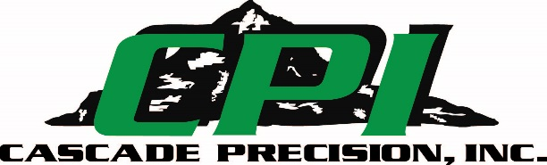
Business Address:
35700 SE Bluff Rd.
Boring, Or 97009

Contact:
Jake Cansler, President
Phone: (503)663-9506
Fax: (503)663-0845
Email:jake@cascadeprecision.com

Website:
www.cascadeprecision.com

DUNS #:
032986671

CAGE Code:
6Q0K4

Certifications:
ISO 9001:2015 Certified
AS9100D Certified

NAIC’s:
332710-Machine Shop
333995-Fluid Power Cylinder and Actuator Manufacturing
332216-Hand Tool Manufacturing
332510-Hardware Manufacturing
332721-Precision Turned Product Manufacturing

CAPABILITIES STATEMENT
OVERVIEW
Cascade Precision, Inc. is a private, service disabled veteran owned machine shop that has been in business since 1979. Proudly made in the USA, CPI provides excellent service and quality manufactured components and assemblies. From small parts to large, there is nothing that CPI’s engineers, craftsman and management cannot handle for your manufacturing needs.
MISSION
Cascade Precision Inc. provides superior customer service by delivering precision machined parts through turnkey manufacturing processes from engineering to final assembly.
CAPABILITIES
- High-Quality, Low-cost Component Manufacturing
- High Performance Pneumatic Cylinder Manufacturing
- High Pressure Hydraulic Cylinder and Control System Manufacturing
- Offer design solutions
- Precision Measuring
- Assembly
- Laser Engraving
EQUIPMENT
- 1 Mitutoyo Crysta-APEX CNC CMM with CAT1000 MCOSMOS software
- 1 Mitutoyo Manual CMM with GEOMeasure software
- 1 ST-Industries Video Inspection system with M3 Metrology software
- 2 Mori-Seiki NLX Mill Turn centers with dual spindles
- 1 DMU 50 5 axis mill
- Aggie Wire EDM
- 8 Doosan Lathes w/up to 20” diameter turning capacity
- 1 CMX 1100 4th Axis vertical mill
- 1 Mori Seiki NH4000 DCG Horizontal mill
- 3 Doosan 40 x 20 vertical mills
- 3 Fadal 40 X 20 Vertical mills
- 3 Okuma40 X 20 Vertical Mills
